Factor each expression completely.
1. x² + 2x – 35 2. x² – 10x + 16 3. 4x² – 25 4. $2x^{2}+4x-6$

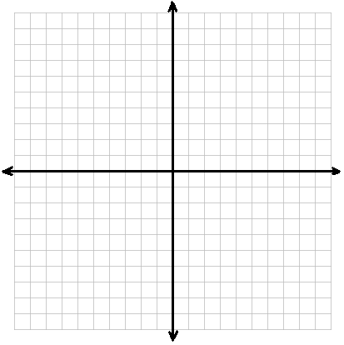
4. Graph g(x) = $({x-4)}^{2} + 1$ by finding the vertex and y-intercept, then plotting those two points and a
mirror image.

Vertex:________ y-int:_____

5. Find the zeros of the function by factoring: f(x) = 5x² + 10x

6. Find the zeros of the function by graphing: f(x) = – x² – 4x + 10
7. Solve the equation using square roots: (x – 1)² + 3 = 14

8. Find the roots of: x² + 8x + 20 = 0

Solve using any method.
9. 2x² – 16x + 32 = 0 10. x² – 6x = 11 11. x² + 3x +1 = 0 12. 3x² + 7 = – 5

13. For f(x) = x² – 2x – 8, find the following and graph the function.
a) direction of opening_______ b) AOS ____________
c) vertex ______ d) max/min & what is it?______________________
e) y-intercept_________ f) x-intercepts(zeroes)______________
g) vertex form____________________

14. The path of a soccer ball is modeled by the function h(x) = -0.005x² + 0.25x, where h is the height of
the ball in meters and x is the horizontal distance in feet that the ball travels in meters. What is the
maximum height that the ball reaches?

15. A company has determined that their per-item profit, P, can by modeled by the function
P(x) = – 12x² + 47x – 40, where x is the selling cost.

a) What is the maximum profit that the company will make per item?
b) How much profit would the company make if the items were sold for $1.50?
c) How much did they sell the items for if they had a profit of $4 per item?

