4.5 Notes: Solving by Square Root
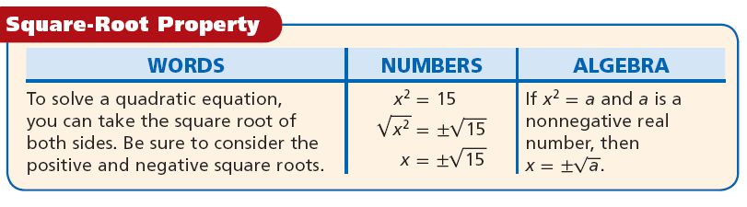
Example 1: Solve 4x² + 11 = 59 Example 2: Solve 4x² – 20 = 5

Example 3: Solve 3x² – 4 = 68 Example 4: Solve x² + 12x + 36 = 28

Example 5: Solve x² + 8x + 16 = 9 Example 6: Solve x² – 10x + 25 = 27

