***5.2 Properties of Quadratic Functions in Standard Form***

**QOD(question of the day)** ☺: Can you define, identify and graph a quadratic function? How about using their maximum or minimum to solve a problem?

The **axis of symmetry** is the line through the vertex of a parabola that divides the parabola into two congruent halves.

The **standard form** of a quadratic function is *f*(*x*)= *ax*2 + *bx* + *c*, where *a* ≠ 0.

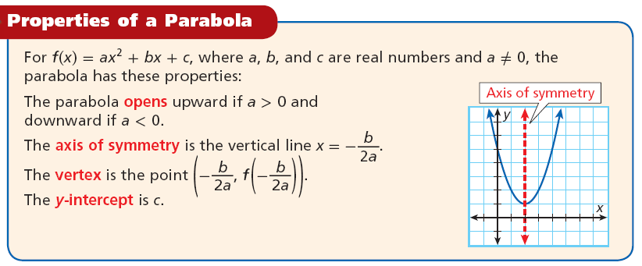

Example 1: Consider the function *f*(*x*) = 2*x*2 – 4*x* + 5.

1. Determine whether the function opens up or down. How do you know?
2. Find the AOS(axis of symmetry).
3. Find the vertex.

1. Now find the y-intercept.
2. Now we shall sketch the graph of this function.

Example 2: Consider the function *f*(*x*) = –*x*2 – 2*x* + 3.

a) Determine whether the function opens up or down. How do you know?

b) Find the AOS(axis of symmetry).

c) Find the vertex.

d) Now find the y-intercept.

e) Now we shall sketch the graph of this function.

Example 3: Consider the function *f*(*x*) = –2*x*2 – 4*x*.

a) Determine whether the function opens up or down. How do you know?

b) Find the AOS(axis of symmetry).

c) Find the vertex.

d) Now find the y-intercept.

e) Now we shall sketch the graph of this function.

Example 4: Consider the function *f*(*x*) = *x*2 + 3*x* – 1.

a) Determine whether the function opens up or down. How do you know?

b) Find the AOS(axis of symmetry).

c) Find the vertex.

d) Now find the y-intercept.

e) Now we shall sketch the graph of this function.

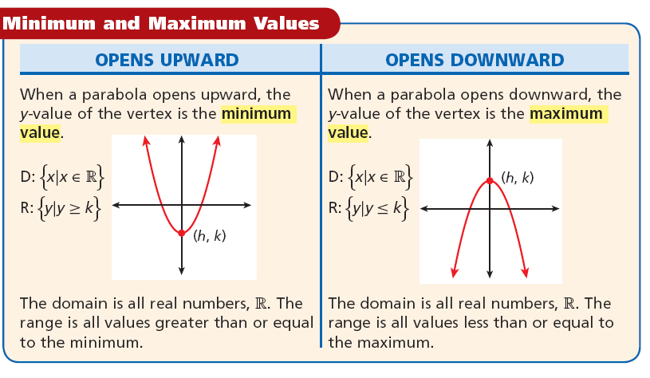

The minimum/maximum value is the

***y-value*** at vertex!!! It is ***NOT*** the

ordered pair that represents the

vertex!

Example 5: Find the maximum or minimum value of f(x) = – 3x2 + 2x – 4. Then state the domain and range of the function.

Example 6: Find the minimum or maximum value of f(x) = x2 – 6x + 3. Then state the domain and range of the function.

Example 7: Find the minimum or maximum value of f(x) = – 2x2 – 4. Then state the domain and range of the function.

Example 8: The average height ***h*** in centimeters of a certain type of grain can be modeled by the function h(r) = 0.024r2  – 1.28r + 33.6, where ***r*** is the distance in centimeters between the rows in which the grain is planted. Based on this model, what is the minimum average height of the grain, and what is the row spacing that results in this height?

Example 9: The highway mileage ***m*** in miles per gallon for a compact car is approximately by m(s) = –0.025s2 + 2.45s – 30, where ***s*** is the speed in miles per hour. What is the maximum mileage for this compact car to the nearest tenth of a mile per gallon? What speed results in this mileage?

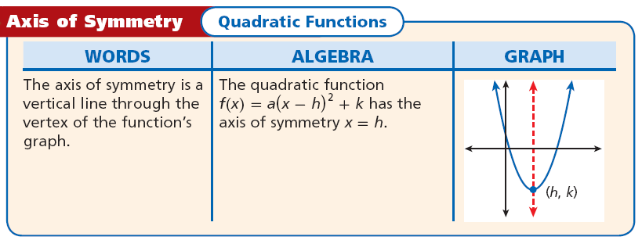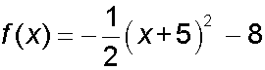Example 1: Identify the axis of symmetry for

1Example 2: Identify the axis of symmetry for