2.8 Absolute Value Inequalities HW
Graph each inequality. List the vertex coordinates and be ACCURATE when plotting points! Make sure to show whether you include or are NOT including the absolute value function in the answer.
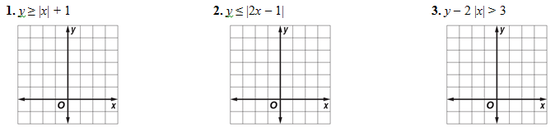
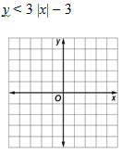
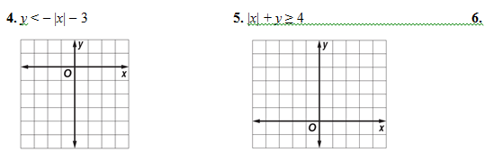
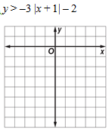
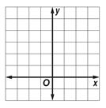
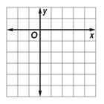
7. $\left|-x+2\right|+y>-1$ 8. $y≤\left|-x+1\right|+4$ 9.

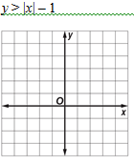
10.

11. Enter the data in your calculator and find the linear regression line. What is the correlation coefficient?
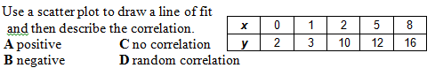
Find y when x=3. Find x when y=11.

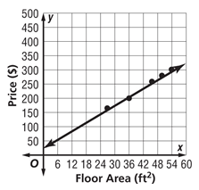
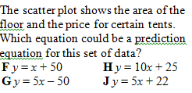
12.

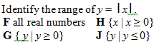
13.

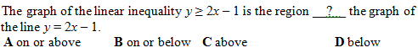
14.

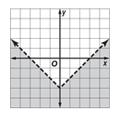
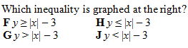
15.

