2.7 Absolute Value Function Transformations HW
For each graph, list the transformations that occur. Then, write the corresponding absolute value function that goes with each graph.
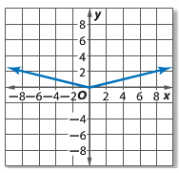
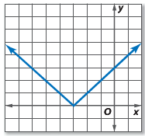
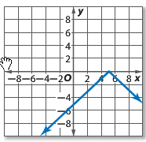
1. 2. 3.

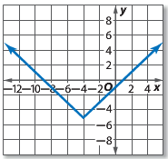
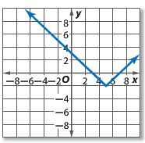
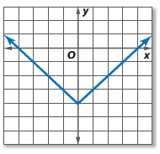
4. 5. 6.

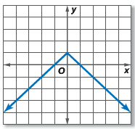
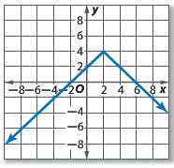
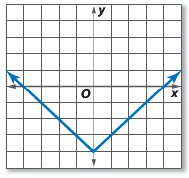
7. 8. 9.

For the following absolute value functions, list the transformations that occur. Then sketch the graph.
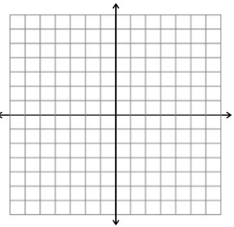
10. f(x) = $\left|x+1\right|$ 11. f(x) = $-\left|x\right|$ 12. f(x) = $\left|x\right|-1$ 13. f(x) = $\left|3x\right|$

14. f(x) = $\left|x+6\right|$ 15. f(x) = $\left|-x\right|$ 16. f(x) = $\left|x-3\right|+4$ 17. f(x) = 2$\left|x\right|$

18. f(x) = $-2\left|x+3\right|$ 19. f(x) = $\left|-2x-1\right|$ 20. f(x) = $\left|2x\right|$ – 1 21. f(x) = $\left|2x-2\right|$

