2.6 Piecewise Functions
OBJECTIVES: Can you write & graph piecewise functions? Can you use piecewise functions to describe real-world situations?
VOCAB: piecewise function
step function

A piecewise function is a function that is a combination of one or more functions. The rule for a piecewise function is different for different parts, or pieces, of the domain. For instance, movie ticket prices are often different for different age groups. So the function for movie ticket prices would assign a different value (ticket price) for each domain interval (age group).

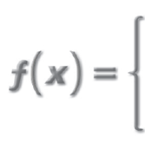
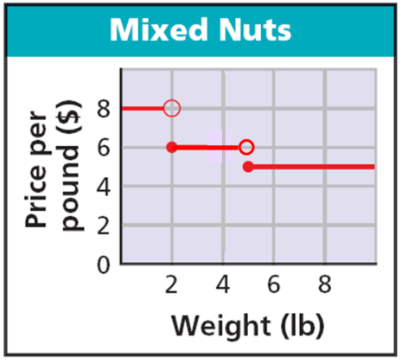
A piecewise function that is constant for each interval of its domain, such as the ticket price function, is called a step function. You can describe piecewise functions with a function rule.
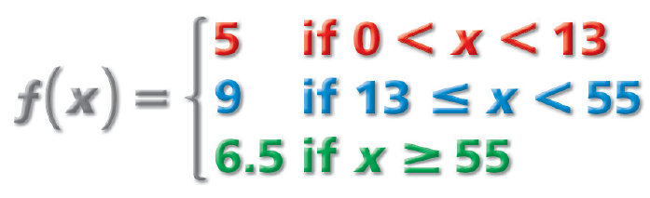

Read this as “f of x is 5 if x is greater than 0 and less than 13, 9 if x is greater than or equal to 13 and less than 55, and 6.5 if x is greater than or equal to 55.”

To evaluate any piecewise function for a specific input, find the interval of the domain that contains that input and then use the rule for that interval.

Example 1: Evaluate for x = – 1 & x = 4. Example 2: Evaluate for x = – 1 & x = 4.

2x + 1 if x$≤$2 2^{x} if x$≤$ – 1
h(x) = g(x) =
x² – 4 if x$>$2 5x if x$>$ – 1

Example 3: Evaluate for x = – 1 & x = 3. Example 4: Evaluate for x = – 1 & x = 3.

12 if x$<$ – 3 3x² + 1 if x$<0$
f(x) = 15 if – 3$≤$x$<6$ g(x) =
20 if x$≥6$ 5x – 2 if x$≥0$

Example 5: Graph the piecewise function. Example 6: Graph the piecewise function.
4 if x$≤-1$ – 3x if x$<2$
f(x) = f(x) =
– 2 if x$>-1$ x + 3 if x$≥2$

