2.5 Transformations
A transformation is a change in the position, size, or shape of a figure.
A translation, or slide, is a transformation that moves each point in a figure the same distance in the same direction.
Notice that when you translate left or right, the x-coordinate changes(horizontal translation), and when you translate up or down, the y-coordinate changes(vertical translation).
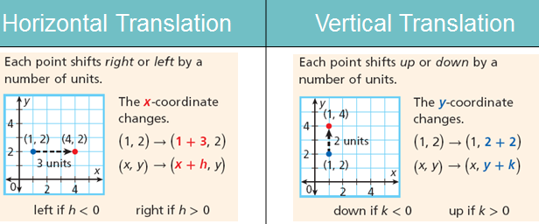

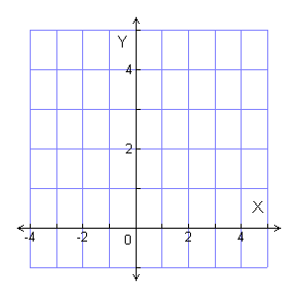
Example 1: 5 units right Example 2: 2 units left & 2 units down

Example 3: 4 units right Example 4: 1 unit left & 2 units down

A reflection is a transformation that flips a figure across a line called the line of reflection. Each reflected point is the same distance from the line of reflection, but on the opposite side of the line.
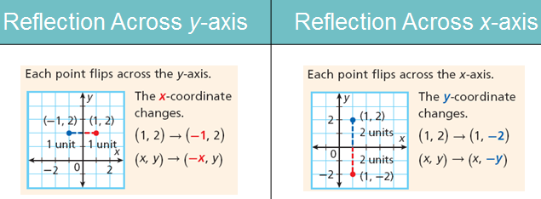

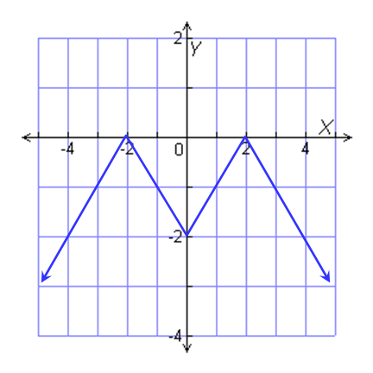
Example 5: translation 2 units up Example 6: reflection across x-axis

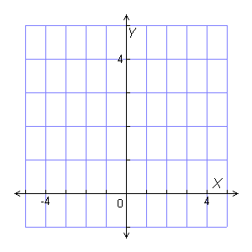
Example 7: translation 3 units right Example 8: reflection across x-axis

Imagine grasping two points on the graph of a function that lie on opposite sides of the y-axis. If you pull the points away from the y-axis, you would create a horizontal stretch of the graph. If you push the points towards the y-axis, you would create a horizontal compression.

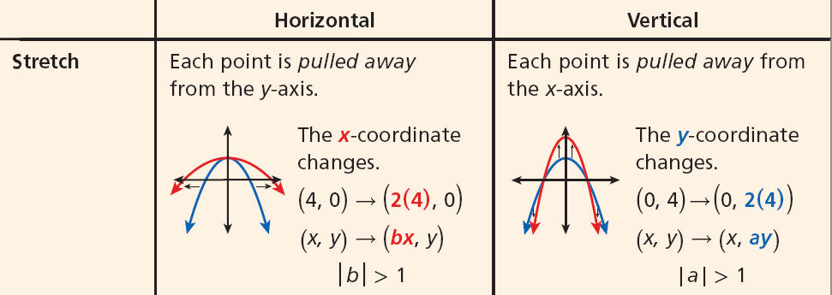

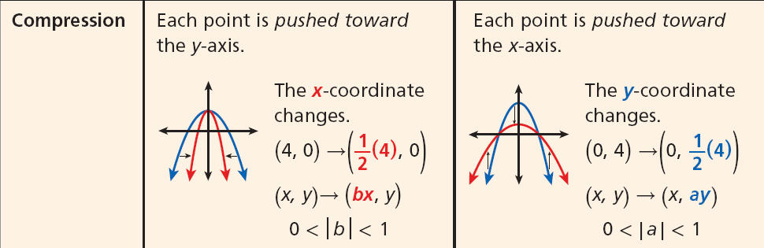

Example 9: horizontal stretch Example 10: vertical stretch by
by a factor of 3 a factor of 2
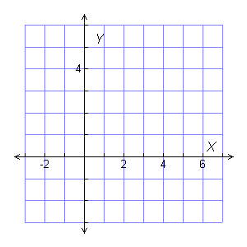

Example 11: reflection across y-axis Example 12: vertical compression
followed by translation 3 units up. By a factor of ½ followed by a
translation right 2 units.

