2-5 Skills Practice
Scatter Plots and Lines of Regression

For Exercises 1–3, complete parts a–c.
a. Make a scatter plot and a line of fit, and describe the correlation.
b. Use two ordered pairs to write a prediction equation.
c. Use your prediction equation to predict the missing value.

1. | x y  1 1  3 5  4 7  6 11  7 12  8 15  10 ?  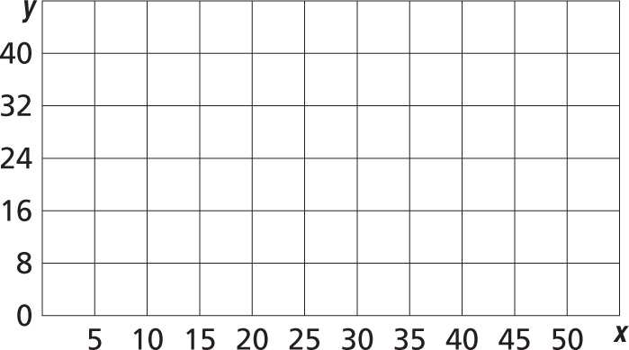
2. | x y  5 9  10 17  20 22  25 30  35 38  40 44  50 ?
3. | x y  1 16  2 16  3 ?  4 22  5 30  7 34  8 36
