2-5 Study Guide and Intervention
Scatter Plots and Lines of Regression

Scatter Plots and Prediction Equations A set of data points graphed as ordered pairs in a coordinate plane is called a scatter plot. A scatter plot can be used to determine if there is a relationship among the data. A line of fit is a line that closely approximates a set of data graphed in a scatter plot. The equation of a line of fit is called a prediction equation because it can be used to predict values not given in the data set.

Example: STORAGE COSTS According to a certain prediction equation, the cost of 200 square feet of storage space is $60. The cost of 325 square feet of storage space is $160.
a. Find the slope of the prediction equation. What does it represent?
Since the cost depends upon the square footage, let x represent the amount of storage space in square feet and y represent the cost in dollars. The slope can be found using the formula m = $\frac{y_{2} - y_{1}}{x_{2} - x_{1}}$. So, m = $\frac{160 - 60}{325 - 200}$ = $\frac{100}{125}$ = 0.8

The slope of the prediction equation is 0.8. This means that the price of storage increases 80¢ for each one-square-foot increase in storage space.

b. Find a prediction equation.
Using the slope and one of the points on the line, you can use the point-slope form to find a prediction equation.
y – $y_{1}$ = m(x – $x_{1}$) Point-slope form
y – 60 = 0.8(x – 200) ($x_{1}$, $y_{1}$) = (200, 60), m = 0.8
y – 60 = 0.8x – 160 Distributive Property
y = 0.8x – 100 Add 60 to both sides.
A prediction equation is y = 0.8x – 100.

Exercises
1. SALARIES The table below shows the years of experience for eight technicians at Lewis Techomatic and the hourly rate of pay each technician earns.

Experience (years) | 9 | 4 | 3 | 1 | 10 | 6 | 12 | 8
Hourly Rate of Pay | $17 | $10 | $10 | $7 | $19 | $12 | $20 | $15

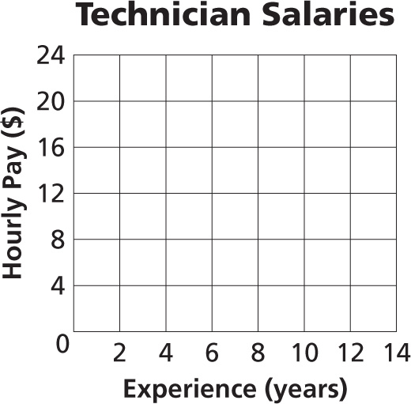
a. Draw a scatter plot to show how years of experience are related to hourly
rate of pay. Draw a line of fit and describe the correlation.

b. Write a prediction equation to show how years of experience (x) are
related to hourly rate of pay (y).

c. Use the function to predict the hourly rate of pay for 15 years of experience.

2-5 Study Guide and Intervention (continued)
Scatter Plots and Lines of Regression

Lines of Regression Another method for writing a line of fit is to use a line of regression. A regression line is determined through complex calculations to ensure that the distance of all the data points to the line of fit are at the minimum.

Example: WORLD POPULATION The following table gives the United Nations estimates of the world population (in billions) every five years from 1980-2005. Find the equation and graph the line of regression. Then predict the population in 2010.

Year | Population (billions)
1980 | 4.451
1985 | 4.855
1990 | 5.295
1995 | 5.719
2000 | 6.124
2005 | 6.515
2010 | ?
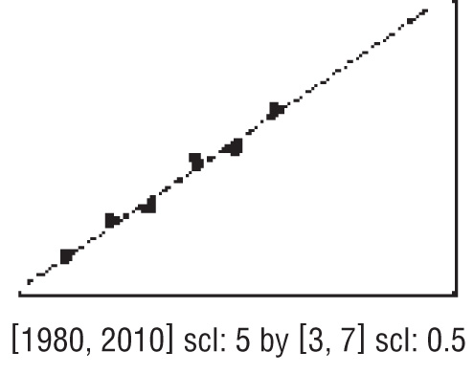
Source: UN 2006 Revisions Population database

Step 1 Use your calculator to make a scatter plot.

Step 2 Find the equation of the line of regression. The equation is about y = 0.083x – 160.180.

Step 3 Graph the regression equation.

Step 4 Predict using the function. In 2010 the population will be approximately 6.984 billion.

Exercise
1. The table below shows the number of women who served in the United States Congress during the years 1995-2006. Find an equation for and graph a line of regression Then use the function to predict the number of women in Congress in the 112th Congressional Session.

Congressional Session | Number of Women
104 | 59
105 | 65
106 | 67
107 | 75
108 | 77
109 | 83
Source: U. S. Senate

