  - Notes – Rate of Change & Slope
Quick Check: * State whether f(x) = 2 + x² is linear.
* State whether x – y = –6 is linear.
* Write the equation 2 – y = 10x in standard form.
* Write the equation 2y = $\frac{1}{3}$x – 7 in standard form.
* The initial fee to join a gym is $200. It costs $55 per month to have a membership.
Write a function for the total cost, C(x) of having a membership for x months. What
is the cost of having a membership for 18 months?

Can you find the rate of change?
Can you determine the slope of a line?

Examples: 1) COLLEGE ADMISSIONS In 2004, 56,878 students applied to UCLA. In 2006,
60,291 students applied. Find the rate of change in the number of students applying
for admission from 2004 to 2006.
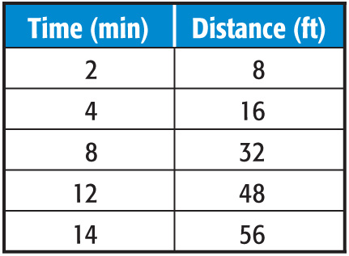
2) Find the rate of change for the data in the table.

3) BUSINESS Refer to the graph below, which shows data on the fastest-growing restaurant chain in
the U.S. during the time period of the graph. Find the rate of change of the number of stores from
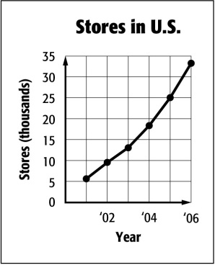
2001 to 2006.

4) COMPUTERS Refer to the graph. Find the average rate of change of the percent of households
with computers in the United States from 2000 to 2004.

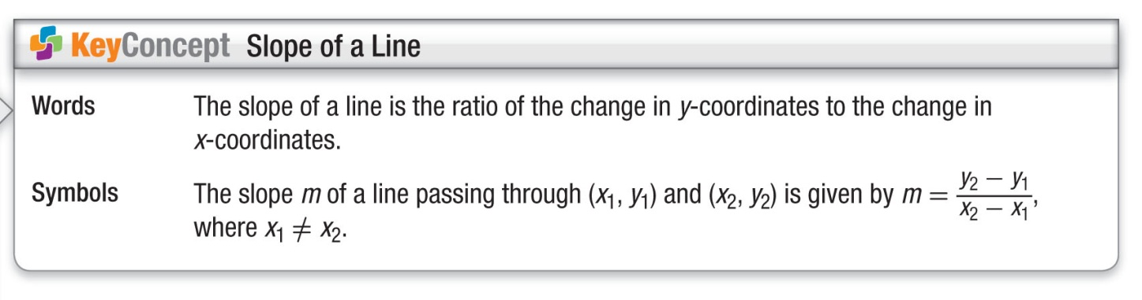
Examples: 5) Find the slope of the line that passes through (–1, 4) and (1, –2).

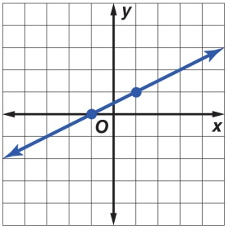
6) Find the slope of the line that passes through 7) Find the slope of the line.
(9, –3) and (2, 7).

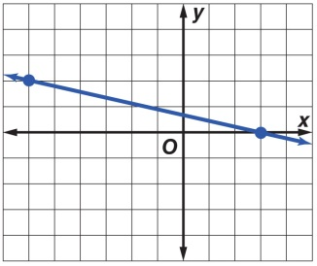
8) Find the slope of the line.

