1-5 Practice
Solving Inequalities

Solve each inequality. Then graph the solution set on a number line.

1. 8x – 6 ≥ 10
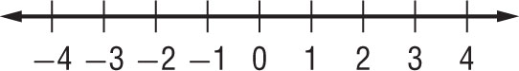
2. 23 – 4u < 11
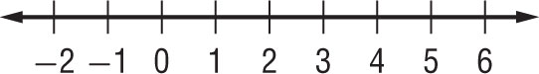

3. –16 – 8r ≥ 0
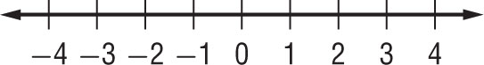
4. 14c < 9c + 5
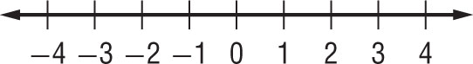

5. 9x – 11 > 6x – 9
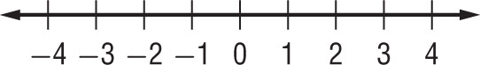
6. –3(4w – 1) > 18
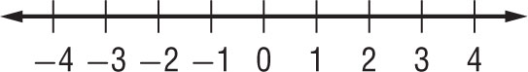

7. 1 – 8u ≤ 3u – 10
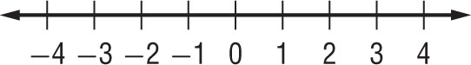
8. 17.5 < 19 – 2.5x
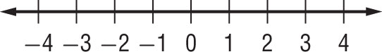

9. 9(2r – 5) – 3 < 7r – 4
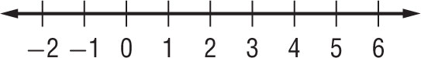

10. 1 + 5(x – 8) ≤ 2 – (x + 5)
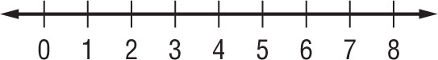

11. $\frac{4x-3}{2}$ ≥ –3.5
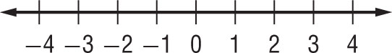
12. q – 2(2 – q) ≤ 0
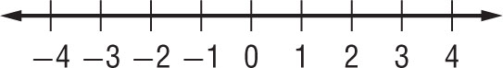

13. –36 – 2(w + 77) > –4(2w + 52)
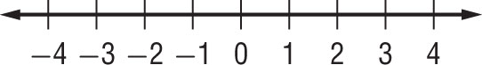

14. 4n – 5(n – 3) > 3(n + 1) – 4
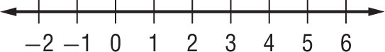

Define a variable and write an inequality for each problem. Then solve.

15. Twenty less than a number is more than twice the same number.

16. Four times the sum of twice a number and –3 is less than 5.5 times that same number.

17. HOTELS The Lincoln’s hotel room costs $90 a night. An additional 10% tax is added. Hotel parking is $12 per day. The Lincoln’s expect to spend $30 in tips during their stay. Solve the inequality 90x + 90(0.1)x + 12x + 30 ≤ 600 to find how many nights the Lincoln’s can stay at the hotel without exceeding total hotel costs of $600.

18. BANKING Jan’s account balance is $3800. Of this, $750 is for rent. Jan wants to keep a balance of at least $500. Write and solve an inequality describing how much she can withdraw and still leave enough for rent and a $500 balance.

